

**Web Engineering**

**Assignment # 1**

Submitted by

**NAZIA SULEMAN | 298022**

Submitted to

Sir. Najeeb Ullah

**Landing Page:**

**Hero section:**





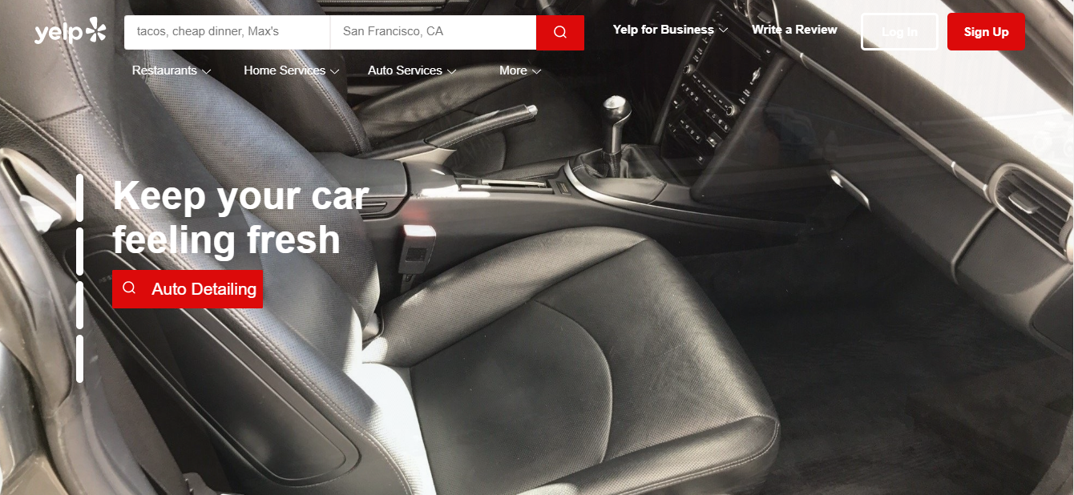

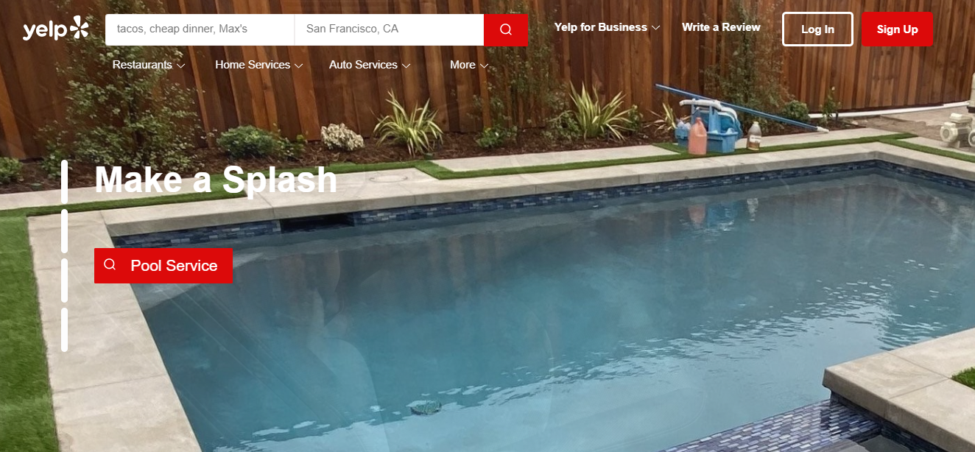

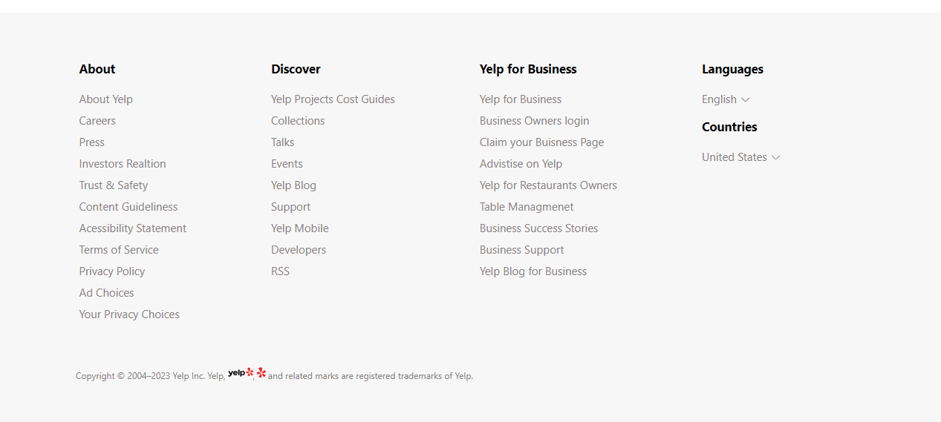

**Login Page:**

By clicking on the login button in the nav bar of landing page, this page will open

**Sign up page:**

By clicking on the sign up button on the nav bar of the landing page, the below sign up page will open



